Maningning Street Nitang Avenue Gulod Novaliches Q.C.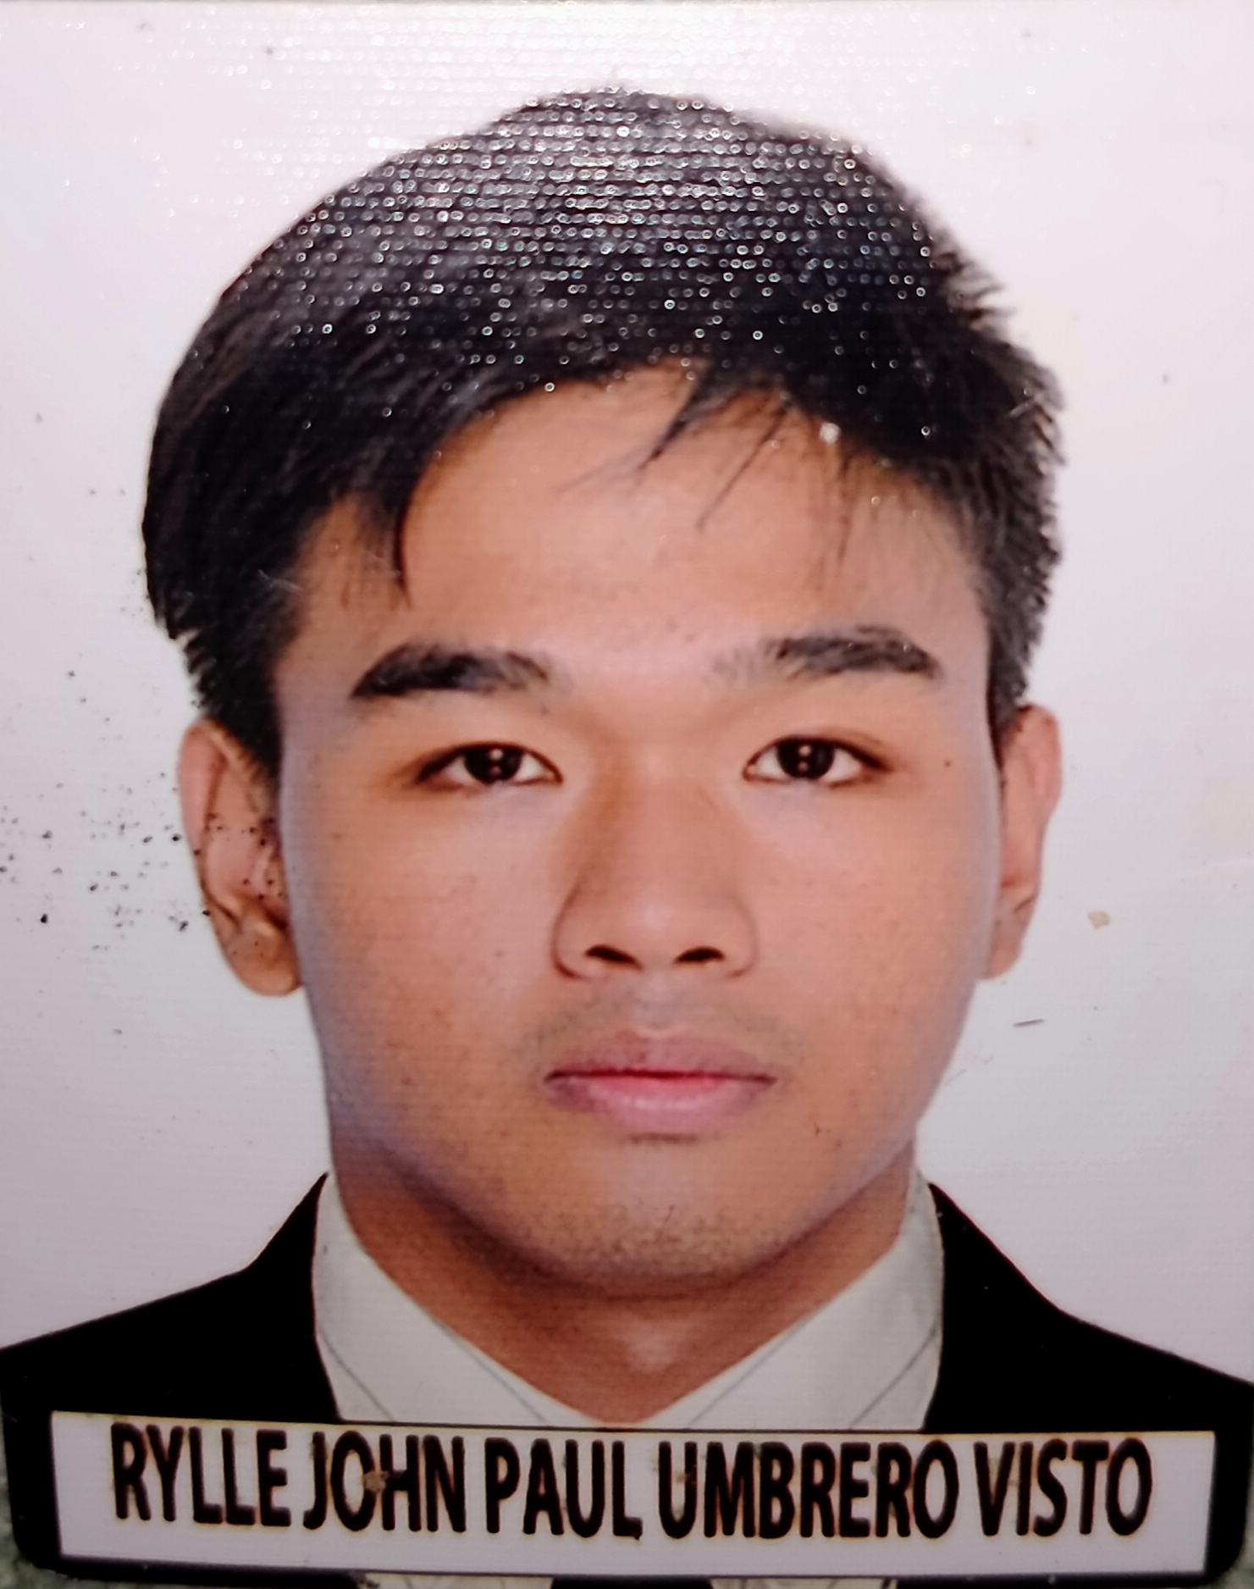

Gulod Novaliches Quezon,City

09684426865/09312113551

ryllevisto13@gmail.com

**RYLLE JOHN PAUL UMBRERO VISTO**

**PERSONAL DATA**

Date of Birth: July 17, 2000

Place of Birth: Maura Aparri,Cagayan

Civil Status: Single

Citizenship: Filipino

Religion: Catholic

Father’s Name: Robinson M. Visto

Mother’s Name: Olivia A. Umbrero

**EDUCATIONAL BACKGROUND**

Elementary Rosa L. Susano Elementary School

Gulod Novaliches Quezon,City

2007-2013

Junior High San Bartolome High School

San Bartolome Novaliches Quezon,City

2013-2017

Senior High Electron College of Technical Education

San Bartolome Novaliches Quezon,City

2017-2019

College Bestlink College of the Philippines

Kaligayahan Novaliches Quezon,City

2021-Present

**SKILLS AND ABILITIES**

*Computer Literate

*Software Developing(VB.net, C#, Java)

*Website Developing(HTML, Jquery, Javascript, PHP, Angular, Bootstrap, Css)

*Networking(Mikrotik)

*Manual and Automated Penetration Testing

*PC and Network troubleshooting